How will I be successful this year?
Success in this classroom is defined by the students’ growth in mastery of the curriculum. Students who apply their effort towards the learning goal often reach mastery level quickly. Likewise, students who follow all behavioral expectations find academic success in class.

I have questions about one of the policies above: (Write your question) _________________________________________
_____________________________________________________________________________________________________
****OR****
I understand all and agree to the expectations above: (Please sign) _____________________________________________

How will I be graded?
Grades will reflect the total points earned throughout the quarter.
Points will be earned through:
- Classwork
- Projects
- Labs
- Tests & Quizzes
- Interactive Notebook content & organization

Expectations:
- Students will be expected to abide by the PCSB Code of Conduct at all times.

- Students will be expected to abide by the BCHS Pirate code at all times. (School-wide expectations are posted in every classroom.)

- Students will be expected to abide by the classroom expectations & procedures to ensure student safety.

What do I need for class?
Both in person and MyPCS students should be prepared EVERYDAY with:
- BCHS AVID BINDER
- ONE subject spiral notebook
- Personal supply of pens/pencils/erasers
- Glue stick
- Small scissors
- Colored pencils or crayons
- Highlighter

How will I learn in class?
This year will be different in the use of technology to deliver instruction virtually to some students. MyPCS students will interact with content using Canvas which is accessible through Clever. There is also a Canvas App for mobile devices. All students will be exposed to content through:
- Teacher led direct instruction
- Collaboration with peers and staff through engaging activities (Labs)
- Grouped literacy activities
- Student led inquiry projects

What will I learn in class?
This course will expose you to the study of living organisms. Topics and content will prepare you for your EOC and for future science courses. See the back side for a general overview of topics.

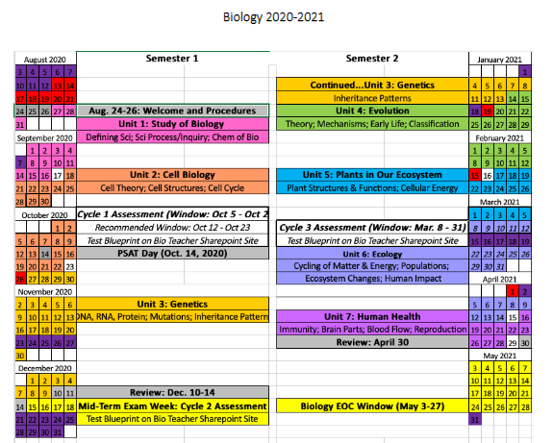
***ALL dates are subject to change. This is ONLY a possible outline of the year**

