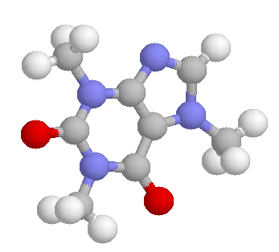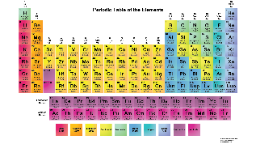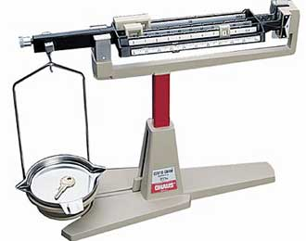
Welcome to AP Chemistry!

Teacher: Ms. Mitsch
Room: 4-319
Email: mitschh@pcsb.org

COURSE MATERIALS

- A scientific or graphing calculator
- The Princeton Review for AP Chemistry
- Closed lab shoes (must cover the entire top of the foot)
- Binder with 2 tabs, paper, writing utensils

- Phones CANNOT be used as calculators in class or at home – it is essential that you learn to use and feel comfortable with your calculator for the AP exam.
- See https://apstudent.collegeboard.org/apcourse/ap-chemistry/calculators-and-commonly-used-equations to see a list of acceptable calculators.
- You must have shoes every day. You may leave an extra pair in a lab drawer if you frequently wear sandals.
- If you are unable to purchase any of these supplies, please let me know by emailing me at mitschh@pcsb.org.

DEVICES
- In-person students are strongly encouraged to bring their own devices to class.
- Devices should be used for academic purposes only during class time.
- Students who bring devices will do so at their own risk. BCHS and Ms. Mitsch are not responsible for these devices.
- Students who bring devices agree to abide by the Pinellas County Schools Bring Your Own Device Agreement that can be found at the following website: https://www.pcsb.org/cms/lib/FL01903687/Centricity/domain/176/pcs forms/2-3199.pdf

THE AP EXAM
- Friday, May 7th at 8:00am
- All students enrolled in the course must plan to take the AP Chemistry exam at the above date and time. Plan accordingly as makeups are rarely permitted by the College Board.
- Students who fail to sit for the AP exam will be given a zero for their second semester exam grade. (District policy)
- Students are required to take (cannot exempt) a teacher-made midterm exam which will be given during the regularly scheduled exam period.

GRADING POLICIES
Late work will not be accepted for any reason. All late work will receive a zero.
- Binder and FRQ Journal Checks
  - We will utilize a virtual notebook for FRQ journals this year. You may keep a hard copy, but pictures must be uploaded.
  - Class notes may be graded in lieu of a formal binder check due to COVID-19.
  - Organization of materials must be completed before class on the day of the check. You will lose points for last minute organization of these materials.
  - Binder and journal checks cannot be put off unless you were absent the class before the check.
- Assignments
  - All assignments will be turned in digitally on canvas unless otherwise stated by Ms. Mitsch.
  - Ms. Mitsch will not accept emailed assignments for any reason.
  - All assignments must have all work shown or no credit will be given. This is an understood requirement for every assignment.
- Labs
- Any pre-lab assignments or procedure planning must be completed prior to lab. You will not be permitted to start lab until the pre-lab assignment is complete.
- Points will be deducted from the lab if you fail to clean your lab station.
- Students who miss lab will be given an alternative on canvas. The due date will be extended by 1 day.
- Quizzes and Tests
  - Short quizzes will be given on a regular basis to assess understanding, and tests will be given at the end of each unit.
  - Tests and quizzes may be proctored via teams for virtual students and will only be available during class times or scheduled makeup times.
  - Tests and quizzes will be timed and the time limit will not be extended without a documented accommodation.
- Extra credit
- It is recommended that you complete all extra credit assignments, even if you do not currently need it. You may find you need it later in the quarter.
- Extra credit will not bring you from an F to a C, or a D to a B! Do not expect extra credit to compensate for poor study skills and poor work completion all quarter.
- Extra credit will be offered on a whole-class basis only. Do not ask if you can have additional extra credit to improve your grade.
- No late extra credit will be accepted!

ABSENCES
General Absence Policies:
- Students are responsible for all material covered on the day of the absence.
- Tests will not be pushed back due to absences throughout a unit.
- You must get all missed assignments the day you return from your absence.
- Students will have 1 day for each day absent to turn in work they missed from their absence.
- No absent work will be accepted after the last day of the quarter for any reason.
- Students with extensive absences (a week or more) must come during tutoring times to plan a makeup schedule for their absences before the following class period. Students may also complete it via email. Without completing this schedule, test and lab dates will not be extended, and the 1 day for each day out rule will be strictly enforced (if you are absent on the due date, it must be submitted via email).

TEST AND QUIZ MAKE-UPS
- Alternative forms will be used for test and quiz make-ups.
- Test and quiz makeups must be scheduled, even for virtual students
- You are responsible for all information you missed due to absences.
- Retakes will not be provided for a test or quiz taken as a makeup.

LAB SAFTEY
Lab safety is extremely important and ensures the safety of all students in the classroom.
- Students are required to wear closed-toed shoes, safety goggles, and tie back long hair for all in-person labs! Students should have lab appropriate shoes every day. Please note that if the shoe does not completely cover the top of your foot, you cannot use them as lab shoes. If you frequently wear sandals, it is recommended that you purchase/bring in shoes especially for lab and store them in a lab drawer.
- Students who are removed from lab due to lab safety violations or students who do not bring appropriate shoes will not be permitted to participate in lab that day or make up the lab at a later date. They will receive a zero for the lab assignment.
- Students who talk or fail to pay attention to instructions and safety information will not be permitted to complete the lab.
- Students are expected to apply common sense during lab, and follow all instructions given. Please see the lab safety contract for more information and specific policies.

ACADEMIC INTEGRITY
All assignments are considered individual work unless specifically stated otherwise by the teacher!!! This means that any evidence of identical answers is considered academic dishonesty. Claiming that you were unaware a certain assignment was individual work is not an excuse for plagiarism or cheating.

All work must show evidence of independent thinking. Group work or lab assignments will still require every student to analyze and explain on their own. Group work is not an excuse to turn in identical assignments. You must understand, and be able to explain every answer on your paper. If you can’t, this is academic dishonesty.

Providing your work to others through any means for any reason is academic dishonesty. Providing work to others will result in both students earning a zero and administration will be notified. Do not provide anyone work for any reason. Students will frequently ask to “reference” another student’s work resulting in copying and zeros on assignments.

