DUE: by 8/19 for Extra Credit - or - by 8/23 for Q1 Binder
Boca Ciega High School E. J. Sullivan, M.A.T.
2019-2020 School Year sullivaneri@pcsb.org
AP 2-D Art & Design (Digital Focus)
AP Drawing (Digital Focus)
General Classroom Syllabus

Dear Student and Parent/Family/Guardian,

My name is E. J. Sullivan, and I would like to welcome you to AP Art here at Boca Ciega for the
2019-2020 school year! I am proud of your commitment to the Arts! The inclusion of the Arts in academic settings has been shown, time and time again, to dramatically increase student performance and success.
I look forward to sharing with you how rewarding an education that includes the Arts can be!
Syllabus and Classroom Management Plan

Our actual AP Art Course Description (students will soon know it as the Big Purple .pdf) is an incredibly important document that we will use often. However, it’s a huge .pdf and so we will start diving into it the first day. This syllabus, and its following sections, are pertinent to just our classroom and our school.

Students: much like citizens creating a constitution, we create a living document – our CLASS AGREEMENTS - during the first days of school. After their completion, they are posted to our class website on FOCUS.

Parents / Guardians: Please see our Focus website, during the 2nd full week of school, for what we produce!

Prerequisites and Required Supplies

AP Art & Design (Digital) does not have a prerequisite course, but it is highly recommended that class members have recent experience in Art, and already have a developing Portfolio. It is strongly suggested that students take AP Art as Juniors or Seniors. Sophomores should ideally present a Portfolio to Mr. Sullivan. AP Art is not usually advisable for Freshman.

AP Drawing (Digital) has a prerequisite course at BCHS of AP Art & Design

Although all required supplies for our class will be provided by the generosity of Pinellas County taxpayers through the amazing Pinellas County Schools Referendum, students are encouraged to have:
a personal USB drive larger than 8 GB, and a paper sketchbook for class.

Although also not required, a DSLR (recommended) or quality point-and-shoot digital camera will be highly useful for our course. A limited number of these cameras are available for check-out from our BCHS Digital Art Lab!
(see Cameras on Page 5)

General Course and Exam Info

AP Art & Design and AP Drawing are year-long courses. AP Art counts towards the required Fine Arts credit for graduation.

AP Art is a college level course
We may work with college level content (please see Disclaimer on Page 2). Please note that this course demands personal motivation (Students: please see the Artwork and Style commitment on Page 4)
Page 2 of 5
General Course and Exam Info (continued)

Students: Leading up to Portfolio Day you will be encouraged to attend extra class sessions outside of our normal class hours. These sessions typically take place in Semester 2 on select Saturday mornings.

Our course concludes with the required AP Art Portfolio, which is technically due by May 8, 2020. However, students who complete their Portfolios by May 1 may earn an “A” on their Semester 2 BCHS Exam Grade. Students who complete their Portfolios between May 2 and May 8 will earn a maximum grade of a “B” on their Semester 2 BCHS Exam.

The fee for our Exam is paid by Pinellas County Schools. District (PCS) policies are in place that effect AP students and fees - please see the Exam Acknowledgement Contract towards the end of this packet.

Students: you will be excused (SCF = School Function) from all other classes on May 8

Students/Families: multiple field trips to art museums around the region are being planned for this school year! While transportation and admission costs are often covered, meals and other incidental expenses will be your responsibility. Stay tuned for further details!

Art Computer Lab

During this class, students have access some or all of the following equipment: Apple iMac desktop computers, digital cameras, digital drawing tablets, a flatbed scanner, and decent headphones.

We will care for our Lab equipment on a daily basis, and clean our computer lab often. All of Mr. Sullivan’s classes do this as a “real world” routine.

Internet Use

We use the Internet in our class, extensively. We will be online to source imagery and digital tools, research trends in contemporary art, study art history, evaluate technical tutorials, and to view the websites of professional artists. Please note, and this is a challenge for many students in a computer lab: we will have absolutely zero time for other non-academic online pursuits. We have too much amazing Art material to cover!

College Level Work Disclaimer

Please note that in our AP Art class, students have the option of creating, analyzing and investigating college level content. The College Board does not limit student creativity, and therefore students may choose to include imagery and information in their artwork that addresses potentially controversial subjects such as: individual/social/national identity, religion, politics, conflict/war/persecution/class/family struggles, economics, the human form/human body, and other contemporary topics (to name a few). That being said, please bear in mind that many students choose to work on Portfolios that are not controversial, whatsoever. AP Portfolios are truly a matter of personal taste and motivation. Stay tuned for updates on this.

Communication

Communication is essential to our class. The best way to contact Mr. Sullivan is through email.

Please share your email on the Student / Family pages. Mr. Sullivan’s email is:

sullivaneri@pcsb.org
Page 3 of 5
Parent/Family Page

GET ON THE MAILING LIST!
Dear BCHS Family,

I want to keep you informed! Please provide an email that I can reach you at!

Parent/Guardian  First Name |  | Parent/Guardian  Last Name
Check one of the following. Please print legibly.
□ Parent / Family / Guardian email :
□ No email, please use the following phone number/s |  | cell:
home: |  | work:
(If using a phone number – please pick the best option for a daytime call)

NAHS DONATIONS and Chaperones NEEDED!
Dear BCHS Family,

BCHS National Art Honor Society (NAHS) needs your help! NAHS is our professional service organization. NAHS supports special student art projects, student art displays, and field trip expenses for art students. Any and all donations are greatly appreciated! We are also in need of back-up chaperones for our field trips to art museums around the region.

Please consider making a donation and becoming a field trip back-up chaperone!

Please Note: BCHS accepts cash and checks*
*Make checks payable to: Boca Ciega High School. All checks must bear the signers name, address and phone number.

Parent/Guardian/Family: please check one and specify the amount you are committing to here:
□ Donating to NAHS | Amount $:
□ Cannot Donate Now (Please Give a Reminder Later to Donate) | Remind me on:
□ Sorry, Cannot Donate This Year
*****Please note: no money or chaperone offers are required for full points on this part of the assignment*****

Parent/Guardian/Family: please consider the following:
Check here if interested in chaperoning field trips | Circle the days you are most often available:  (Field trips take place Tues. – Thurs. or on Saturdays)
□ | Tuesday | Wednesday | Thursday | Saturday

Thank you for supporting the Arts here at THE Boca Ciega High School! Mr. Sullivan

Page 4 of 5
Student Page
First Name |  | Last Name

Class Communication
Email is a big part of our course. Please share the email address that you check the most often!
Email for class info:
(please print legibly)

Prolific Artwork and Style required here!

Please note that our class is heavy on classwork and independent study. Our class is really about your ability to form an exceptional, unique sense of artistic style while producing as much high-quality artwork as possible. You are also expected to become a sophisticated consumer of the Visual Arts. You are expected to become knowledgeable about how contemporary and historical artists use art to frame their cultural experiences. You will be asked to become truly creative, and a master of critical thinking. Your first assignment is to consider if you are truly ready for theses intense challenges that are being presented to you.

Initial Here | Commitment to AP Studio Art & College Level Excellence
 | Yes, I am ready to commit to artistic excellence in AP Art, and I am ready to shoulder the heavy load of classwork and independent study.
 | No, now that I have thought about it for a while, I am asking to be removed from the class roster.

We take CARE of our LAB!

We have an amazing computer lab to work out of and we keep it clean! Professional artists know that high quality tools need to be cared for a on a daily basis.

Please let me know if you are willing to be responsible for caring for our Lab.

Initial Here | Commitment to Lab Care
 | Yes, I will commit to taking care of our equipment and my supplies each time I work in the Art Lab and any other Art Rooms.
 | No, I am not prepared or able to do this.

Page 5 of 5

Sketchbooks: An AP Art Sketchbook is highly recommended!

While not strictly required, a pocket or bag size paper sketchbook or notebook is highly recommended for AP Art. A paper sketchbook is still a huge part of the professional artist’s tool kit. Digital equipment has come a long way, but there’s still nothing quite as intuitive as a paper sketching (especially when out in the field).
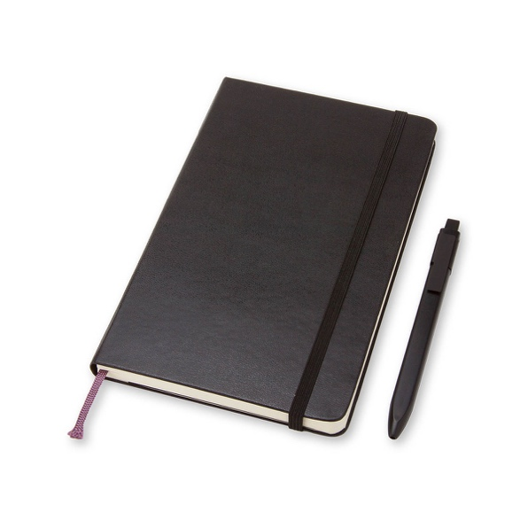
Here are examples of top and low end sketchbook options:

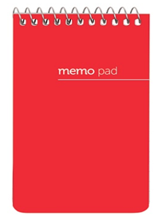
Moleskine notebooks While not glamorous, a basic
are amazing, but pocket-size spiral will do.
expensive. This type of notebook is
The best feature here is very inexpensive.
the thick cover.
(There are many good
off-brand options)
(This type of sketchbook is
preferred)

Daily and weekly planning assignments will be given in sketchbooks.

However, these assignments may be completed (for full credit) digitally, if the student is willing to take the challenge of working on a USB drive or an organized smartphone.
Please Note: Students will be given an 8 GB USB drive as members of our AP class.

Cameras: AP Art Students (Digital) can check-out class cameras

We are fortunate enough to have a growing collection of high-quality DSLR and higher-end point-and-shoot digital cameras. AP Art students may check-out these cameras for out-of-school use at no cost. Students and families who check-out cameras from the BCHS Digital Lab must complete a PCS Equipment contract. If this contract is completed, families and students are responsible for the cost of the equipment if any damages or loss occurs. In other words, you can check-out cameras on a “you break it, you buy it” basis.

AP Art Students are highly encouraged to check-out a camera if they do not have a professional grade camera!

Interested students: see Mr. Sullivan during class for a contract to take home (includes an equipment value list)

BCHS Binders: AP Art is part of the binder system

We are fully involved with the BCHS Binder system, albeit with a smaller section than many classes. Stay tuned for more upcoming details

Students and families are encouraged to be familiar with the 2019-2020 BCHS Binder requirements.

BCHS Digital Art uses Century Gothic font to conserve upwards of 30% of its ink use.

If you have any questions about the following PCS policies, please do not hesitate to contact our school's administrative team by email or at (727) 893-2780.

Pinellas County Schools Advanced Placement Exam Policy

• School Board policy requires that students who do not sit for the AP exam are assigned an F as their final exam grade.

• The cost of each AP Exam is $94, except for Capstone courses which are $142. Assuming a student meets their requirement to sit for the AP exam, this expense is paid by Pinellas County Schools.

• AP Exams ordering deadline is November 1, 2019. Orders cancelled after November 15, will incur a $40 cancellation fee that must be paid by the student. It is advisable that students have a note from their parents approving the drop of the AP course. This fee must be paid before a student drops an AP class.

- See Next Page for AP Exam Acknowledgement Form -

Pinellas County Schools Advanced Placement Exam Acknowledgement Form 2019-20
Congratulations on rising to the challenge of taking an Advanced Placement (AP course). By taking an AP course you are setting your path to college and you have an opportunity to earn college credit at no expense. We know you will work hard and, as a result, you have the potential to be very successful in this course!
Students who take an AP course should be aware of several important pieces of information as outlined below:
- Students are required to take the Semester 1 exam for a yearlong AP course.
- Students are required to sit for the AP exam and do not take a teacher created final exam.
- School Board policy requires that students who do not sit for the AP exam are assigned an F as their final exam grade.
- Advanced Placement exam fees are as follows:
  - The cost of each AP Exam is $94, except for Capstone courses which are $142. Assuming a student meets their requirement to sit for the AP exam, this expense is paid by Pinellas County Schools.
  - The deadline to order AP Exams for yearlong and fall semester courses is November 1st. Orders cancelled after November 15 will incur a $40 cancellation fee that must be paid by the student. This fee must be paid before a student drops an AP class.
  - The $40 unused test fee must be paid by the student who does not sit for his/her AP exam.
It is important to us to know that you have received this information early in the school year. We want you to be committed to being successful in this course and to understand that your commitment includes taking the AP exam. Students who are invested from the beginning of the year have much higher success rates in these courses.
Please complete the table and signature lines below and mark your calendar now for your exams in May to avoid any scheduling conflicts. Your completed form should be returned to any of your AP teachers who will submit it to your AP Exam Coordinator.
AP Course | AP Exam Date | AP Exam Time

Student Signature: Student Name:
Parent Signature: Date:

